Using Small Area Estimates to Create Family Planning Indicators
Small area estimates (SAE) are used to create indicators at geographic units smaller than those included in survey data. Most survey data, such as the Demographic and Health Surveys (DHS), have sample frames powered to create estimates at the national and one administrative level below the national level. With the growing interest in decentralization and decision making at lower levels of government, SAE offer the opportunity to provide data from surveys previously unavailable.
When choosing a method for calculating SAE, we prioritized the ability to use open-source software, use a personal computer, and produce estimates in a short period of time. We selected the kernel estimator approach, implemented by the PrevR package in R. For aggregation, we used QGIS.
Three data sources are used in the creation of the SAE: geospatially linked survey data from the DHS or MICS, gridded population data from WorldPop, and shapefiles of administrative areas (available from The Humanitarian Data Exchange, Diva-GIS, or from governments).
In summary, the SAE are created by estimated modeled surfaces of indicators of interest, weighting by population data, and aggregating to administrative levels. Detailed steps for SAE are listed below.
- Download data
  - For each survey, we download the women’s recode file and the geographic data (cluster data)
  - For each 5 year age group of women of reproductive age (15-49), we download the Geotiff file from WorldPop
  - For administrative boundaries, we download shapefiles
- Prepare population data
  - All 7 age groups are read into R and converted into rasters
  - The rasters are combined to create a summation of all the age groups
  - The final raster is exported
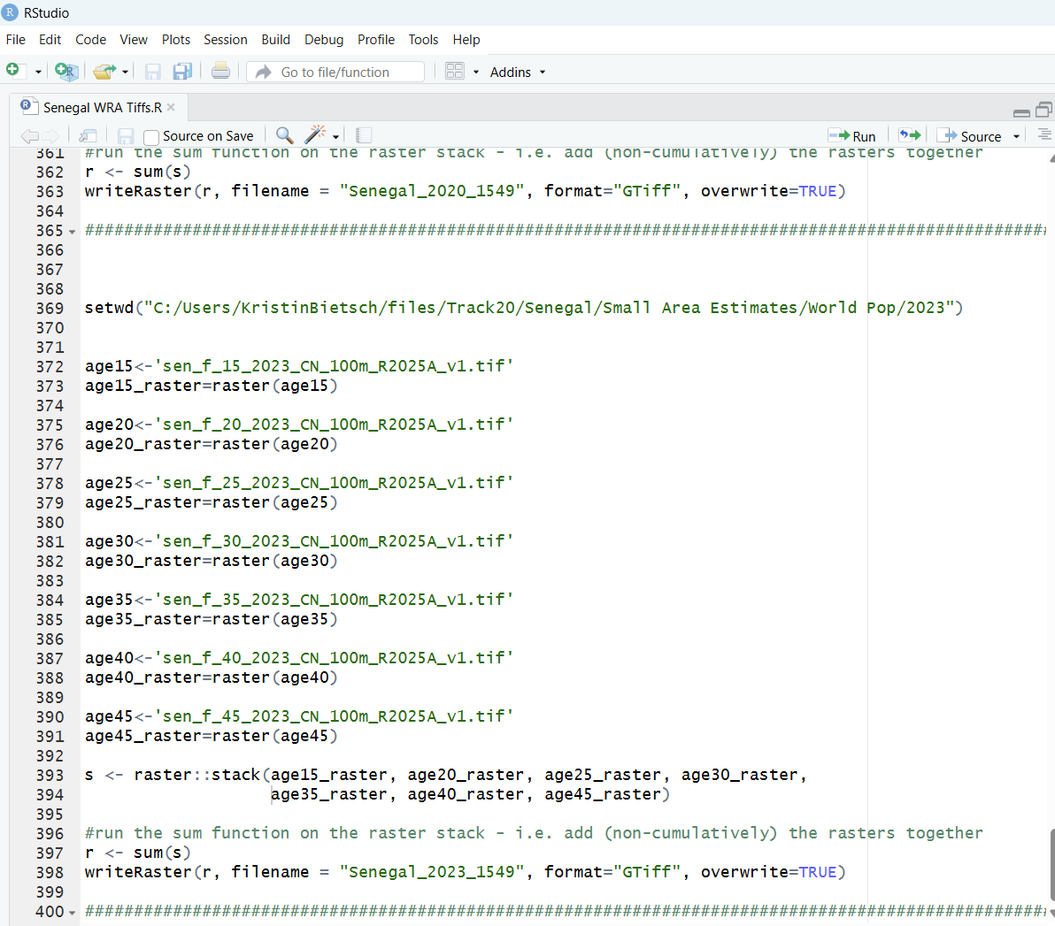
- Create PrevR modeled surfaces
  - Survey women’s recode file and geographic file are read into R
  - If necessary, we filter data to obtain the population of interest
  - Variables of interest are recoded as dichotomous variables
  - Latitude and longitude information from the geographic data is merged into the women’s file
  - The prevR package creates a modeled surface
  - The modeled surface is converted into a raster and transformed from a percentage to a proportion
  - The final rasters are exported
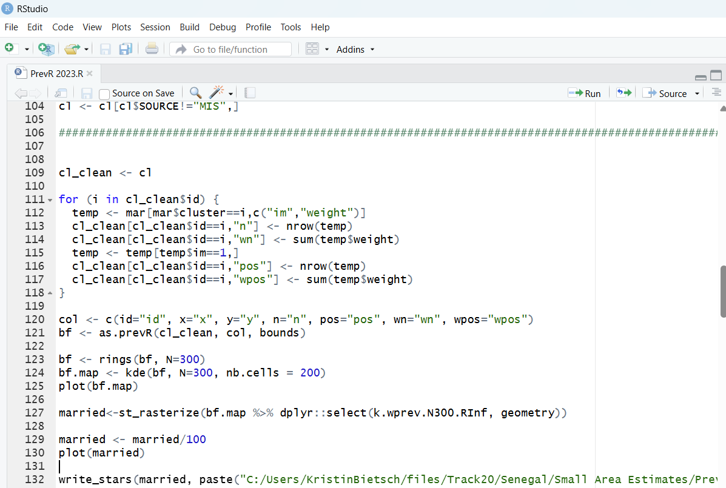
- Create population weighted modeled surfaces
  - The prepared population data from Step 2 and PrevR modeled surfaces from Step 3 are read into QGIS
  - For each variable/population/year combination we need to created a population weighted surface
    - Using the “Raster Calculator” we multiply the number of women by the percent in married (or unmarried) by prevalence (such as mCP) to create a numerator
    - Using the “Raster Calculator” we multiply the number of women by the percent in married (or unmarried) to create a denominator
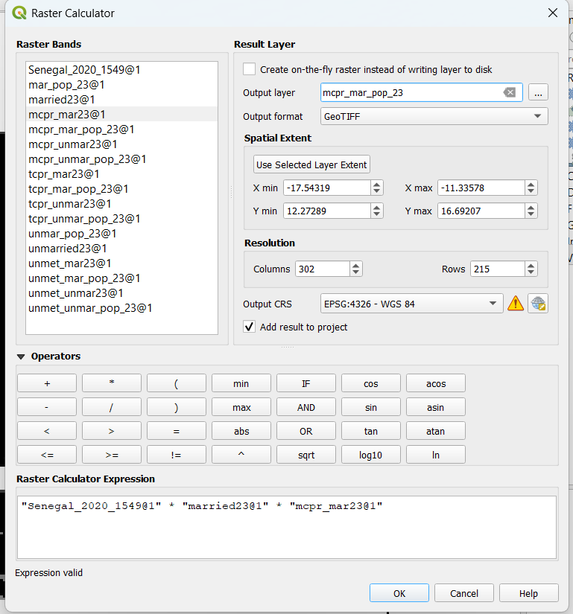
- Aggregate to administrative boundaries
  - We import our administrative shapefile into QGIS
  - Using the processing tool “Zonal Statistics” we aggregate the number of women in each administrative area for the numerators and denominators described in Step 4
  - We export the data as CSV files
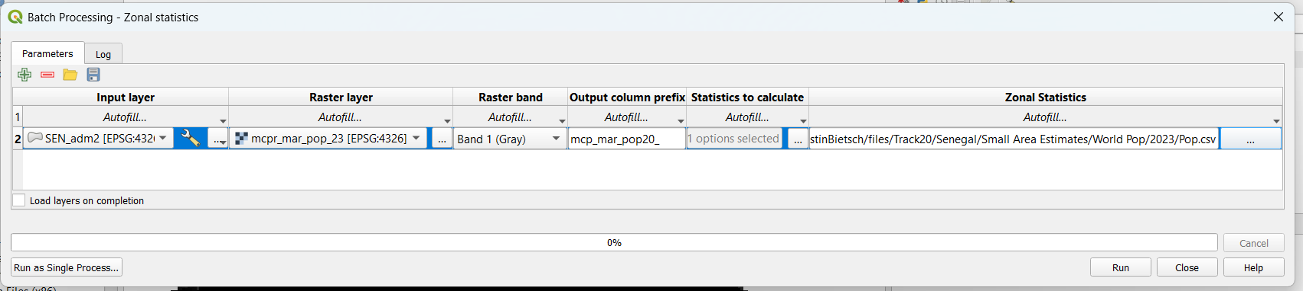
- Final calculations
  - Using R, we read in all of the CSV files produced by QGIS
  - We calculate measures for each administrative area by dividing the numerator by denominator for each of the variables of interest
  - We export this data as a CSV file to share

https://journals.openedition.org/cybergeo/24606
https://cran.r-project.org/web/packages/prevR/index.html
R Core Team (2021). R: A language and environment for statistical computing. R Foundation for Statistical Computing, Vienna, Austria. URL https://www.R-project.org/.
QGIS.org, 2021. QGIS Geographic Information System. QGIS Association. http://www.qgis.org
https://dhsprogram.com/
https://mics.unicef.org/
www.worldpop.org
https://data.humdata.org/
https://diva-gis.org/

